New Driving License

28.05.13

Driving license is a document which states that a person may operate a vehicle of certain category or type. The issuance of new driving licenses has started on 1st March 2013, in accordance with the Law on the Basis of Traffic Safety on the Roads of BiH (“Official Gazette of BiH”, Nos: 6/06, 75/06, 44/07, 48/10, 18/13).

Issuance, extension of validity and replacement of the driving license is carried out by Cantonal Ministries of Interior in FBiH, Ministry of Interior in Republic of Srpska and Public Register in Brcko District, according to the place of residence of the driver. These authorities are also responsible for keeping records of drivers.

**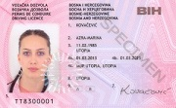          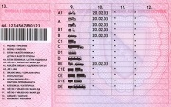**

**HIGHEST SECURITY MEASURES FORDRIVING LICENCE**

The new BiH Driving Licence provides the highest security. Byusing different kinds of security elements everyone can verify thevalidity of the document. The elements can be verified by differentsenses or by using devices.

**NEWEST TECHNOLOGY OF IDENTIFICATION**

Bosnia and Herzegovina is issuing new Driving Licence card for citizens. The image of the holder is personalized with newest technology for color images of identification documents. All information of the holder, such as name, validity and vehicle categories are engraved by a laser system.

**SECURITY ELEMENTS OF DRIVING LICENCE CARD**

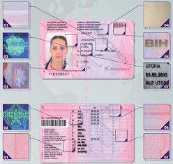

**1. SECURITY BACKGROUND**- Тhe background consist of special security elements such as fine lines, microtext or unique art elements.

**2. ULTRA VIOLET FLUORESCENT IMAGE**- A special security element which consists of fine lines and microtext becomes visible in yellow glowing by viewing the card under UV light.

**3. HOLOGRAPHIC ELEMENT**- This element overlaps the portrait image and changes its appearance by changing the viewing angle.

**4. SURFACE EMBOSSING**- A pattern of stars and microtext is perceptibly embossed into the card front side.

**5. COLOR SHIFTING**- A unique color in shape of a triangle changes from pink to green depending on the viewing angle.

**6. RAINBOW PRINTING**- The color of the background design changes smoothly from pink to grey.

**7. TACTILE EMBOSSED ISSUING DATE**- The issuing date can be felt by touch. It seems that the number is embossed.

Brochure on new driving licenses is available [here](https://www.iddeea.gov.ba/images/stories/PDF/Brosure/VD_brosura.pdf).