Passport

Biometric passport of Bosnia and Herzegovina (civil, service and diplomatic) is issued from 15 October 2009 in accordance with the Law on travel documents of BiH ("Official Gazette of BiH", Nos: [4/97](https://www.iddeea.gov.ba/images/stories/PDF/laws/law_on_travel_documents_of_bih_4-97.pdf), [1/99](https://www.iddeea.gov.ba/images/stories/PDF/laws/law_on_amds_to_the_law_on_td_1-99.pdf), [9/99](https://www.iddeea.gov.ba/images/stories/PDF/laws/law_on_amd_%20t_%20the_law_on_td_9-99.pdf), [27/00](https://www.iddeea.gov.ba/images/stories/PDF/laws/decision_of_hr_on_law_on_td_27-00.pdf), [32/00](https://www.iddeea.gov.ba/images/stories/PDF/laws/decision_amending_the_law_on_td_32-00.pdf), [19/01](https://www.iddeea.gov.ba/images/stories/PDF/laws/law_on_amendment_to_the_law_19-01.pdf), [19/01](https://www.iddeea.gov.ba/images/stories/PDF/laws/law_on_amendments_to_the_law_19-01.pdf), [47/04](https://www.iddeea.gov.ba/images/stories/PDF/laws/law_on_amendments_to_the_law_47-04.pdf), [53/07](https://www.iddeea.gov.ba/images/stories/PDF/laws/decision_of_hr_on_the_law_on_td_53-07.pdf), [15/08](https://www.iddeea.gov.ba/images/stories/PDF/laws/law_on_amendments_to_the_law_15-08.pdf), [33/08](https://www.iddeea.gov.ba/images/stories/PDF/laws/law_on_amds_to_the_law_on_td_33-08.pdf), [39/08](https://www.iddeea.gov.ba/images/stories/PDF/laws/correction_of_the_law_on_td_39-08.pdf)).

Biometric passports are issued by the Cantonal Ministries of Interior in FBiH, Ministry of Interior in Republic of Srpska and Public Register in Brcko District, according to the place of residence. Diplomatic passports are issued by the Ministry of Foreign Affairs of BiH, and service passports are issued by the Ministry of Civil Affairs.

Biometric or E-passport is a document that contains protective elements against counterfeit and electronic chip with which the verification of identity is possible, based on the physiological characteristics of the person who is the subject of the control. Civil, diplomatic and service passports can be distinguished by the embossing on the cover and different colouring and texts inside.

The passports are personalized on the second page. Furthermore the passport contains a contactless chip which is electronically personalized with the holders’ biometric data (photography, signature, fingerprints).

From the aspect of the type of acquisition and protection of data in the chip, this is an extended access control (EAC) passport, This is the latest generation of biometric passports which the Member States of the European Union are supposed to start issuing from 26th June 2012, in accordance with the Regulation EC 444/2009. EAC passports include more digital certificates and special protection of fingerprints compared to the previous generation of biometric passports.

**Basic Information**

Protective elements of the form of the travel document before and after personalization are described in this document.

However, the main power of the system of documents in BiH are the process and procedures implemented during the issuance of documents:

* On-line system which connects all bodies that issue passports and have access to documents on the basis of which the passports are issued (ID Cards, breeder documents- Birth Certificate, Certificate of Citizenship),
* Biometric verification of data is conducted before the personalization,
* Any activity on the system and each data access is logged,
* Multi-layered system of protection is introduced, from physical protection on locations of the competent authorities, through the protection at the network, computers, and the use of digital signatures.

More than 300 physical locations of Ministries of Interior, municipalities- Registry Offices, diplomatic-consular network (DKP) are connected in the system, with over 800 users who are directly involved in the process of issuing passports.

**Passport Covers**

**Passport covers**are made of synthetic material in blue colour, and inscriptions on them are printed in gold colour. The inscriptions on covers differ, depending on the type of passport (civil, diplomatic and service). There is the ICAO sign on the front cover for E-passport.

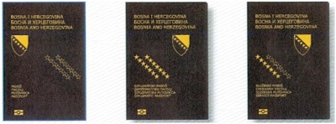

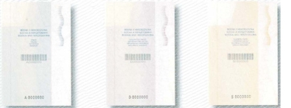

**Passport Endpaper**

**Passport endpaper**is made of protective paper. The background security printing contains positive and negative micro lettering, as well as the intaglio print which can be felt. The paper contains motives that can be seen under UV and IR light, as well as a motive printed in optically variable color.

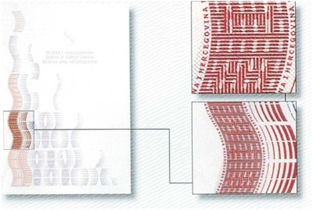

**Passport Title Page**

**Passport title page**contains numbering with a bar-code, as well as number which fluoresces under UV light.

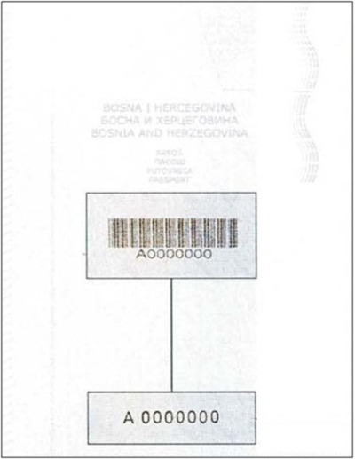

**Passport Data Page**

**Passport data page**is made of protective paper with the watermark with the Coat of Arms of Bosnia and Herzegovina and the inscription “BiH”. The data page is personalized with the holders’ personal data. This page contains secondary image (ghost image) and it is protected with transparent kinematic foil.

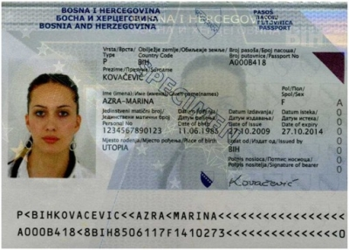

**Passport Inside Pages**

**Passport inside pages** are made of protective paper with the watermark and have an embedded security thread. The inside pages from 3 to 32 are laser perforated with the serial passport number. The background security printing is made up of complex patterns, anti copy structures and includes positive and negative micro letters. The passport is bound together by a multi coloured thread which fluoresces under UV light.

