Motor Vehicle Registration

New vehicle registration system in BiH is implemented since 28 September 2009, in accordance with the provisions of the Law on Roads Traffic Safety Basis in BiH („Official Gazette BiH“No.6/06).

Vehicle registration is carried out by Cantonal Ministries of Interior in FBiH, Ministry of Interior in Republic of Srpska, and Police of Brcko District (Department for Administrative Affairs) in Brcko District of Bosnia and Herzegovina, according to the place of residence of the owner.

**Documents for vehicle registration are:**

* Registration plates;
* Certificate of vehicle ownership;
* Certificate of vehicle registration;
* Internal sticker;
* External sticker.

**Registration plates**

Impersonalized registration plates with security elements for motor vehicles are made of aluminium, flat and smooth with protective retro reflective coating.

Registration plates contain the following protective elements which can be checked with the naked eye:

1. Virtual Security Thread;

2. Watermark;

3. Serial number (serial numbering);

4. Identifying mark of the country (BIH);

5. Font.

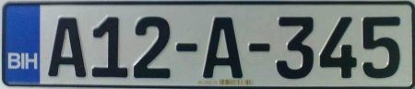

**Security elements of registration plates**

**Virtual Security Thread**is present across the whole horizontal dimension of a plate. One of its elements looks as it is above the plate, and the other one below it.  Durability and clear visibility are ensured during the guaranteed lifetime of the plates. This protective element is visible without any additional special devices, in the daylight and in the night, with short lights of a motor vehicle. It is visible on the plates, set at the specified place on the vehicle, on strong battery lighting at the distance 0-15 meters and must not affect the readability of the registration plate.

**Watermark**is contained in retro reflective foil in the form of the inscription “BiH” in one row, and in the second row in the form of the inscription “БиХ”.  It is visible with the naked eye under the angle of 30⁰ to the plane on which the registration plate is.

**Serial number-**Retro reflective coating of every impersonalized plate contains the unique serial number which is deposited with laser engraving on retro reflective foil in character and 1D bar-code. Serial number is visible with the naked eye and has structure 99999999;

**Identifying mark of the country (BiH) –**design, dimensions and blue background of the identifying logo of the country meet the specifications of Eurologo, according to the Regulation of the Council of the European CommunityNo. 2411/98 (Annex) from 3 November 1998.

**Font -**German FE font.

**Certificate of vehicle ownership**

Certificate of vehicle ownership is made of artificial paper in the shape of three-part form with the dimensions 210x105 mm (unfolded three-part form).

Certificate of vehicle ownership contains the following security protective elements that can be checked with the naked eye:

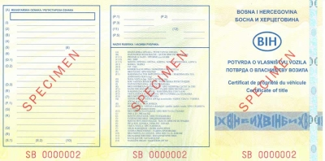

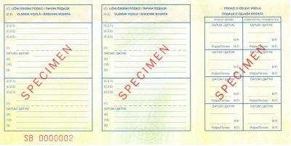

**Security protective elements of the certificate of vehicle ownership**

**Metalized kinegram stripe** is on the outer side of the document. At different angles of observation, it reacts in different colours and contains the inscription “BiH”;

**Watermark**- The form contains bright single-stage watermark in the shape of letters “BiH”, located in the ellipse that are alternately repeated. Watermark can be seen with the naked eye under luminous light source or daily light in the background of the document.

**Iridiscent stripe** is positioned on three places on the inner side of the document. Depending on the angle of the view, those tapes are shown as yellow or light blue.

**Serial number (serial numbering) –**It consists of two letters and seven numbers (e.g. BA 0000001). Serial number is located on three places on the outer side of the document and at one place on the inner side of the document.

**Certificate of vehicle registration**

Certificate of vehicle registration with security protective elements is made of artificial paper in the shape of three-part form with the dimensions 210x105 mm (unfolded three-part form).

Certificate of vehicle registration contains the following security protective elements that can be checked with the naked eye:

* Metalized kinegram stripe;
* Watermark;
* Iridiscent stripe
* Serial number (serial numbering).

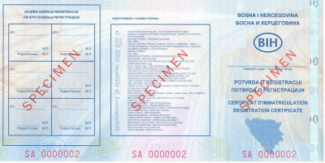

**Security protective elements of the certificate of vehicle registration**

**Metalized kinegram stripe** is on the outer side of the document. At different angles of observation, it reacts in different colours and contains the inscription “BiH”;

**Watermark**- The form contains bright single-stage watermark in the shape of letters “BiH”, located in the ellipse that are alternately repeated. Watermark can be seen with the naked eye under luminous light source or daily light in the background of the document.

**Iridiscent stripe** is positioned on three places on the inner side of the document. Depending on the angle of the view, those tapes are shown as yellow or light blue.

**Serial number (serial numbering) –**It consists of two letters and seven numbers (e.g. AA 0000001). Serial number is located on three places on the outer side of the document and at one place on the inner side of the document.

**Internal sticker**

Internal stickers with security protective elements are made of transparent holographic foil with dimensions 45x60 mm.

Internal stickers have the following security protective elements that can be checked with the naked eye:

* Transparent holographic foil;
* Serial number (serial numbering);
* Effect of self-destruction when trying to lift-off the stickers.

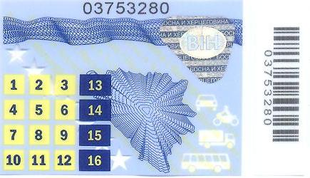

**Security protective elements of internal sticker**

**Transparent holographic foil,**which is contained in the form of internal sticker, changes colour depending on the viewing angle. The foil also contains the inscriptions “BOSNA I HERCEGOVINA “ and “БОСНА И ХЕРЦEГOВИНA” which also change the colour depending on the viewing angle, and diagonal inscription “BOSNAIHERCEGOVINAБОСНАИХЕРЦЕГОВИНА” on the body of the sticker, printed in blue colour. The form contains the inscription in the shape of letters “BiH”, located in the ellipse that are alternately repeated and change colour depending on the viewing angle.

**Serial number**(serial numbering) consists of eight numbers (e.g. 00226693). Serial number of a sticker is located on the top line, i.e. at the top of the sticker.

**Effect of self-destruction when trying to lift-off the stickers –**the sticker has splitting lines on which is destroyed when you try to lift-off from the substrate. Trying to lift-off leads to the destruction of data on the sticker (so called the effect of honeycomp).

**External sticker**

External stickers with security protective elements are made of transparent holographic foil, with dimensions 25x35 mm, and have protective transparent layer which is pasted additionally over the sticker with dimensions 31x41 mm.

External stickers have the following security protective elements that can be checked with the naked eye:

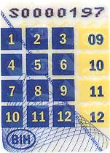

**Security protective elements of external sticker**

**Transparent holographic foil,**which is contained in the form of external sticker, changes colour depending on the viewing angle. The foil also contains the inscriptions “BOSNA I HERCEGOVINA “ and “БОСНА И ХЕРЦEГOВИНA” which also change the colour depending on the viewing angle, and diagonal inscription “BOSNAIHERCEGOVINAБОСНАИХЕРЦЕГОВИНА” on the body of the sticker, printed in blue colour. The form contains the inscription in the shape of letters “BiH”, located in the ellipse that are alternately repeated and change colour depending on the viewing angle.

**Serial number**(serial numbering) consists of eight numbers (e.g. 00099440). Serial number of a sticker is located on the top line, i.e. at the top of the sticker.

**Effect of self-destruction when trying to lift-off the stickers –**The sticker has splitting lines on which is destroyed when you try to lift-off from the substrate. Trying to lift-off leads to the destruction of data on the sticker (so called the effect of honeycomp).