**Tachograph cards**

A smart tachograph is the second generation of a digital tachograph (GEN2) as set out by Regulation (EU) No 165/2014 of the European Parliament and of the Council of 4 February 2014 (Official Journal of the European Union, L60/1) on tachographs used in road transport (hereinafter: the Regulation) and Regulation (EU) No 2020/1054 of the European Parliament and of the Council of 15 July 2020 amending Regulation (EC) No 561/2006 and Regulation (EU) No 165/2014.

|  |  |  |  |  |  |  |  |  |
| --- | --- | --- | --- | --- | --- | --- | --- | --- |
| Equipment and cards compatibility | Tachograph driver cards | | Tachograph company cards | | Tachograph  control cards | | Tachograph workshop cards | |
| Equipment | Gen1 | Gen2 | Gen1 | Gen1 | Gen1 | Gen2 | Gen1 | Gen2 |
| Gen1  (Digital tachograph) | YES | YES | YES | YES | YES | YES | YES | YES |
| Gen2  (Smart tachograph) | YES | YES | YES | YES | YES | YES | NO | YES |

**First generation driver card**

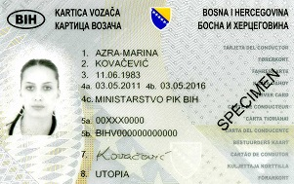   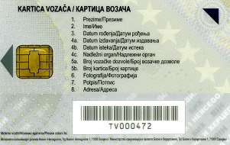

**Second generation driver card**

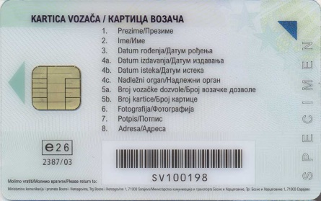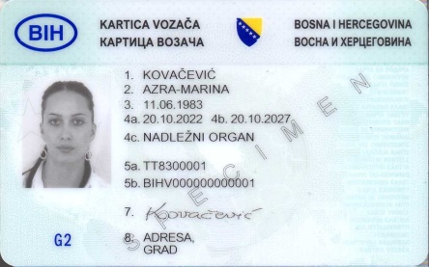

The card is issued upon request for a five-year validity period.

The request is submitted to the entity Ministry responsible for road transport and Sub-department for Public Transportation and Vehicle Maintenance of the Brčko District of Bosnia and Herzegovina;

Competent authority issues a decision on issuance or refusal of the request for issuance of the card;

Personalization and technical processing of the cards and maintenance of registers of personalized cards are done by the Agency for Identification Documents, Registers and Data Exchange of Bosnia and Herzegovina (IDDEEA);

Personalized card shall be delivered at the competent authority where the request for its issuance is submitted.

**First generation company card**

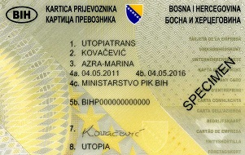   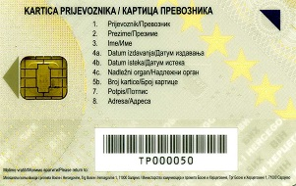

**Second generation company card**

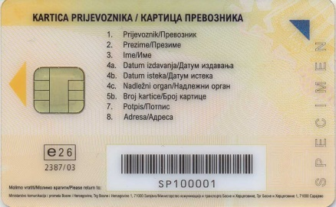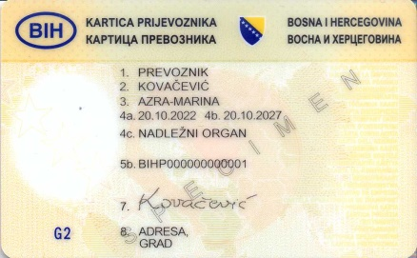

The card is issued upon request for a five-year validity period.

The request is submitted to the entity Ministry responsible for road transport and Sub-department for Public Transportation and Vehicle Maintenance of the Brčko District of Bosnia and Herzegovina;

Competent authority issues a decision on issuance or refusal of the request for issuance of the card;

Personalization and technical processing of the cards and maintenance of registers of personalized cards are done by the Agency for Identification Documents, Registers and Data Exchange of Bosnia and Herzegovina (IDDEEA);

Personalized card shall be delivered at the competent authority where the request for its issuance is submitted.

**First generation control card**

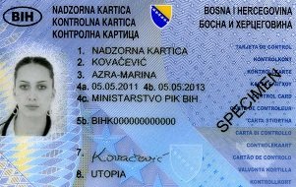 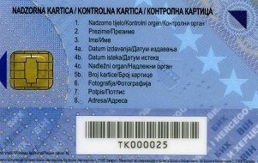

**Second generation control card**

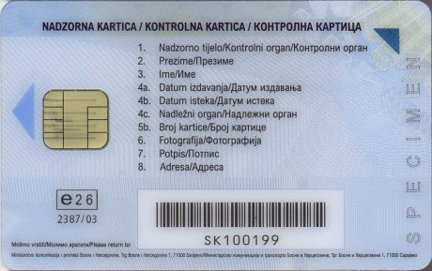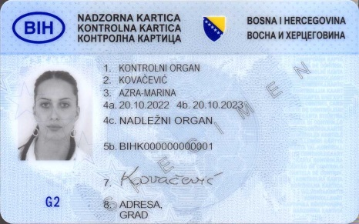

The card is issued upon request for a two-year validity period.

The request is submitted to the entity Ministry responsible for road transport and Sub-department for Public Transportation and Vehicle Maintenance of the Brčko District of Bosnia and Herzegovina;

The card is issued solely in the name of the person authorized to conduct monitoring in accordance with the law;

The competent authority issues a decision on issuance or refusal of the request for issuance of the card;

Personalization and technical processing of the cards and maintenance of registers of personalized cards are done by the Agency for Identification Documents, Registers and Data Exchange of Bosnia and Herzegovina (IDDEEA);

Personalized card shall be delivered at the competent authority where the request for its issuance is submitted.

**First generation workshop card**

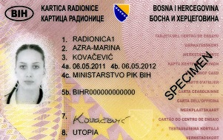   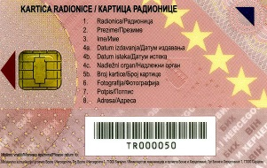

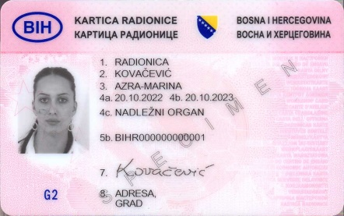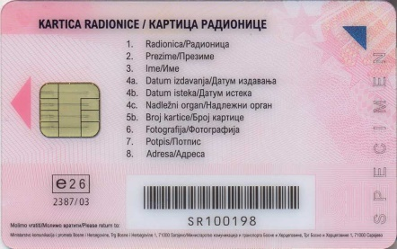

**Second generation workshop card**

The card is issued upon request for a one-year validity period.

The request is submitted to the entity Ministry responsible for road transport and Sub-department for Public Transportation and Vehicle Maintenance of the Brčko District of Bosnia and Herzegovina;

The card is issued solely in the name of a technician who meets specific requirements and must have a security PIN known only to the technician of the workshop - a card holder;

The competent authority issues a decision on issuance or refusal of the request for issuance of the card;

Personalization and technical processing of the cards and maintenance of registers of personalized cards are done by the Agency for Identification Documents, Registers and Data Exchange of Bosnia and Herzegovina (IDDEEA);

Personalized card shall be delivered at the competent authority where the request for its issuance is submitted.